26th April 2016

**Good start for YOKOHAMA Italy in the new Motorsport season**

Exciting Rally action at the weekend for YOKOHAMA Italia in the “Trofeo Rally Terra 2016” with Team Pascoli enjoying smiles all around, following the performance of the superb driver Alessandro Bettega.

Bettega’s performance managed a second place achievement on board a Peugeot 207 S2000 on YOKOHAMA tyres. This is the second time that Alessandro Bettega has partnered with YOKOHAMA in his return to the Rally Championship.

Another well known YOKOHAMA driver, Gigi Ricci on his Subaru Impreza also did exceedingly well finishing in first place in the N group, which will give him plenty of confidence and motivation for the next race in the series.

Further good news came from Nicolò Marchioro who managed to reach the third place of TRT with his Peugeot 207 S2000, and the Power Car Team. Other YOKOHAMA drivers such as Pablo Biolghini and the last champion Mauro Trentin unfortunately encountered some technical issues that did not allow them to reach a good position within the overall table, mostly due to the initial rough conditions of the “Terra Liburna” track.

“I am really glad about the results in this season start” – says Giuseppe Pezzaioli, YOKOHAMA Italia’s Motorsport Manager – “And mostly by the newest cooperation with Alessandro Bettega, another Champion that comes to race with YOKOHAMA, a tyre that has been unbeatable on gravel.”.

The next appointment for the gravel race is on the 29th of May in the “Adriatico”, one of the most exciting and toughest Italian rally challenges of the year.

For further information : [www.yokohama.it](http://www.yokohama.it)

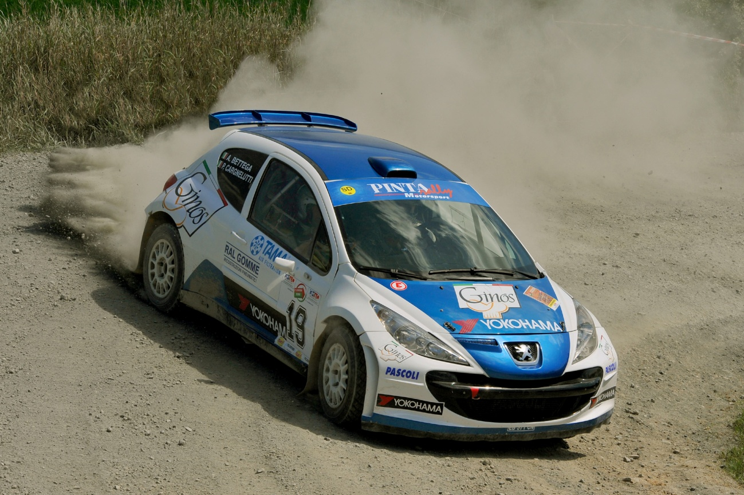

*Alessandro Bettega car*

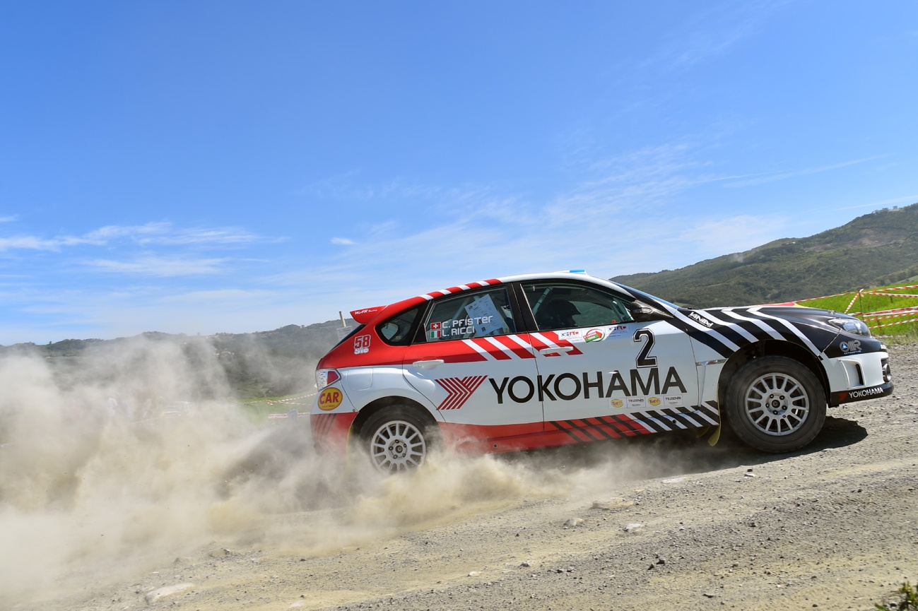

*Gigi Ricci car*